Experiment 07 - Association Rule Mining using Data Mining Tool (RapidMiner)

| Roll No. | 14 |
| --- | --- |
| Name | Ishika S. Devare |
| Class | D15 |
| Subject | Business Intelligence Lab |
| LO Mapped | LO2:  Organize and prepare the data needed for data mining algorithms in terms of attributes and class inputs, training, validating, and testing files.  LO3: Implement the appropriate data mining methods like classification, clustering or association mining on large data sets using open source tools like WEKA |
| Grade |  |

**Implementation -**

**Process -**

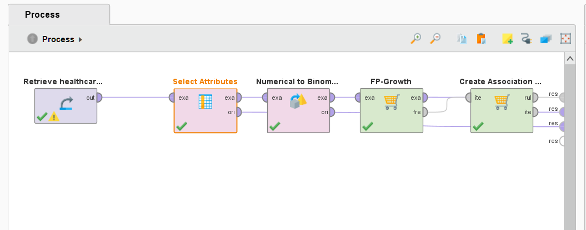

**Association Rules -**

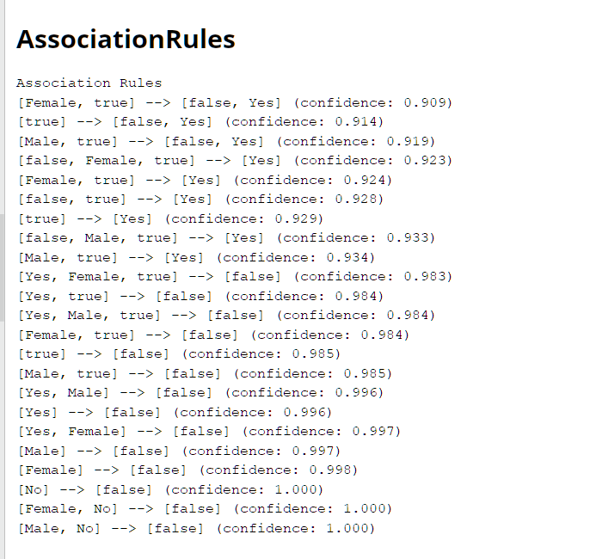

**Graph -** 